**Discord Chat:** [**https://discord.gg/aBeXebZ**](https://discord.gg/aBeXebZ)

(Steep hill algorithm/Greedy) Working version: <https://codeshare.io/Gk0yzx>

You can name your project name and cpp file just have to edit launch, cmake, and package.xml

Project Name: turtlecatch

File Name: hw3.cpp

Launch File: hw3.launch

**catkin_create_pkg turtlecatch**

Create **src** folder: Modify CMake and Project.xml. Add turtlebump.cpp

Navigate to folder and **catkin_make** to compile

Source you build: **source devel/setup.bash**

Without launch file:

roscore

rosrun turtlesim turtlesim_node

rosrun turtlecatch turtlebump

Add launch file o main folder (outside of src).

To launch: **roslaunch turtlecatch hw3.launch**

**Program:**

* Spawns randomly 3 target turtles (Ti) and 4 villain turtles (Xi).
* Spawns mainTurtle to location (0.5, 0.5, 0.0 degrees)
* Find out how to get mainTurtle location
* Check if mainTurtle is near a target
* Check if mainTurtle is near a villain
* Kill target turtle if captured
* Fix Move and relative rotate functions
* Make heuristic function (F(x) = g(x) + h(x))
* Relative rotate function (fixed!)
* Evaluate function checks which point near main turtle is best to move to
* Move function keeps moving the turtle till all three turtles are captured or mainturtle gets caught.

Stuck ! :

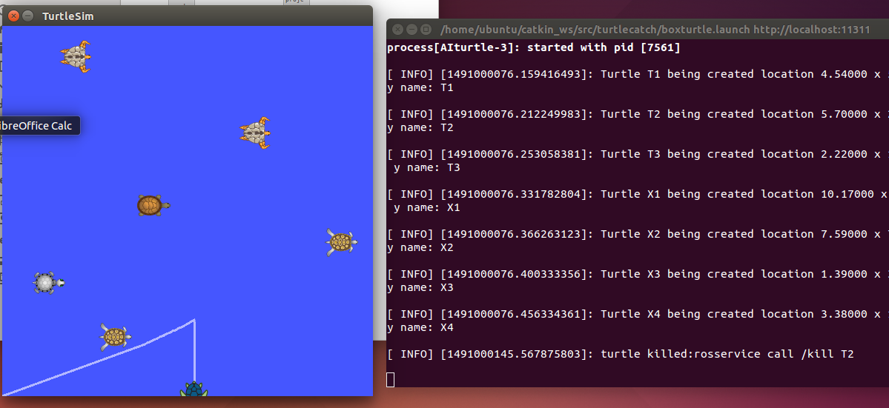

**Stuck! 4/1/17**

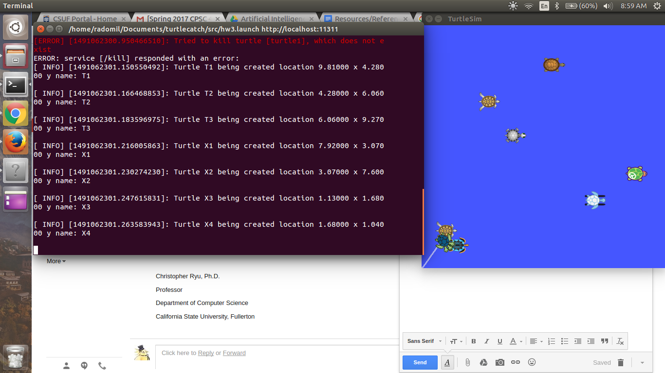

Good :

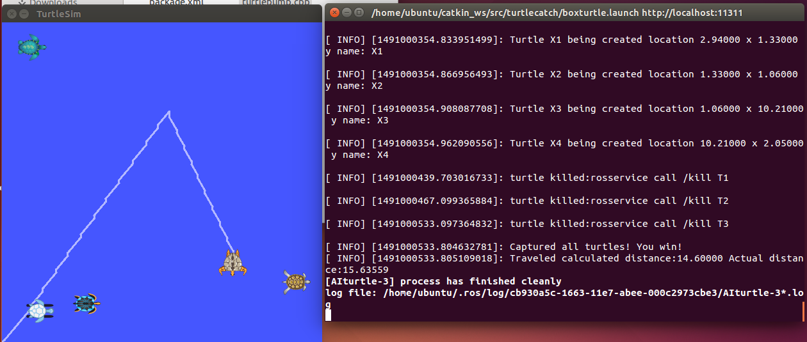

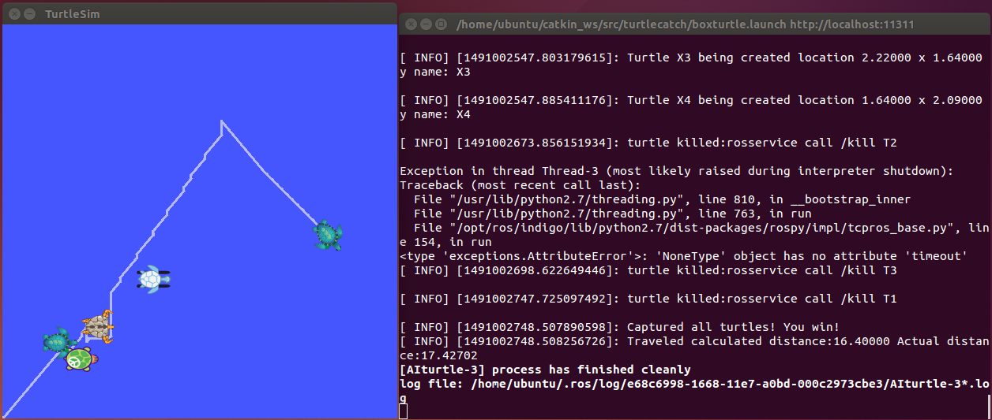

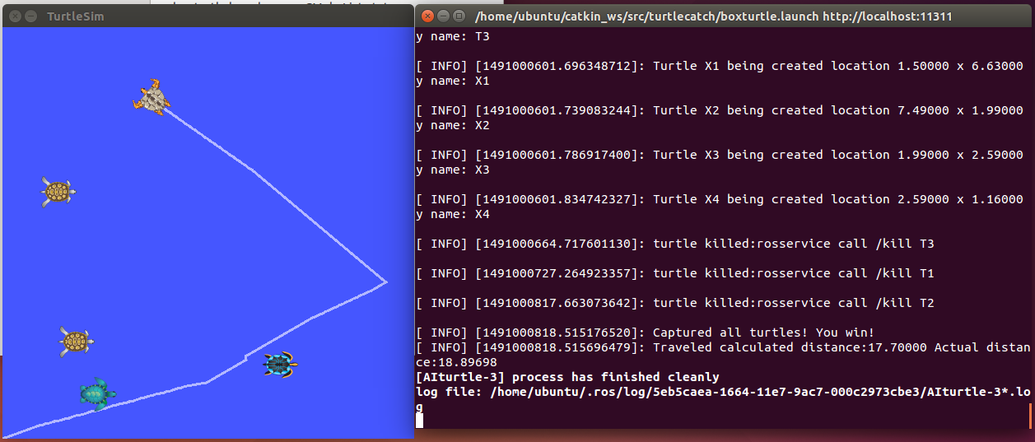

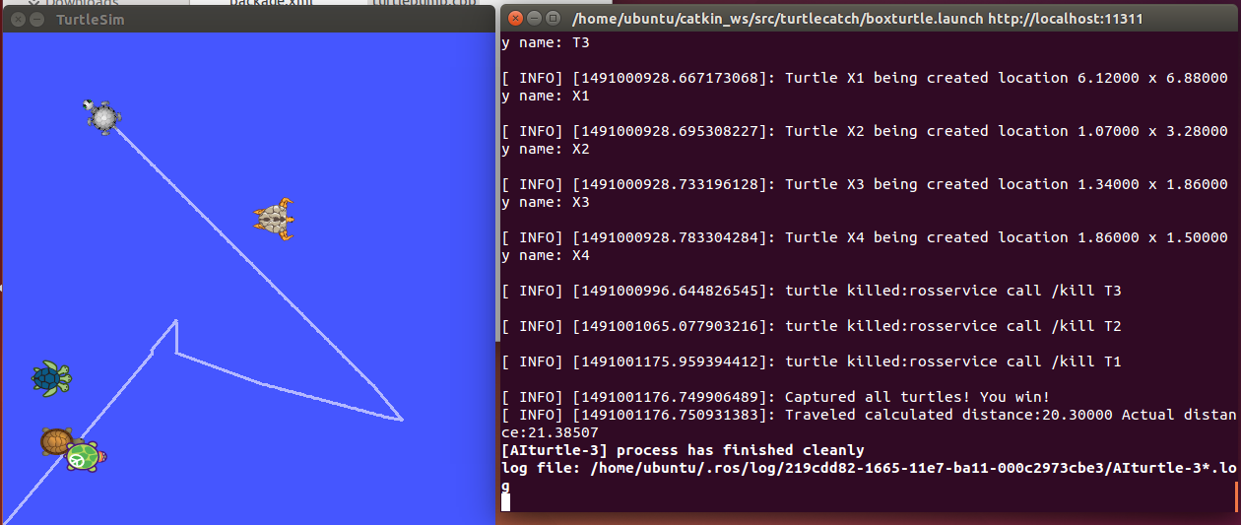

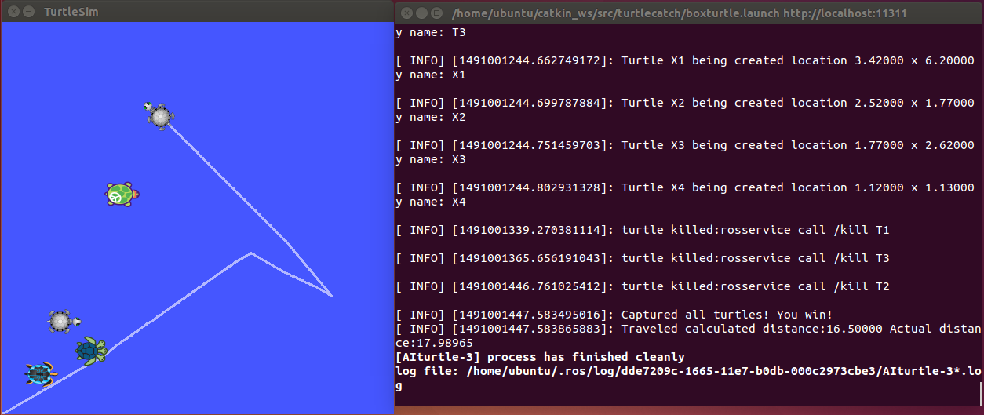

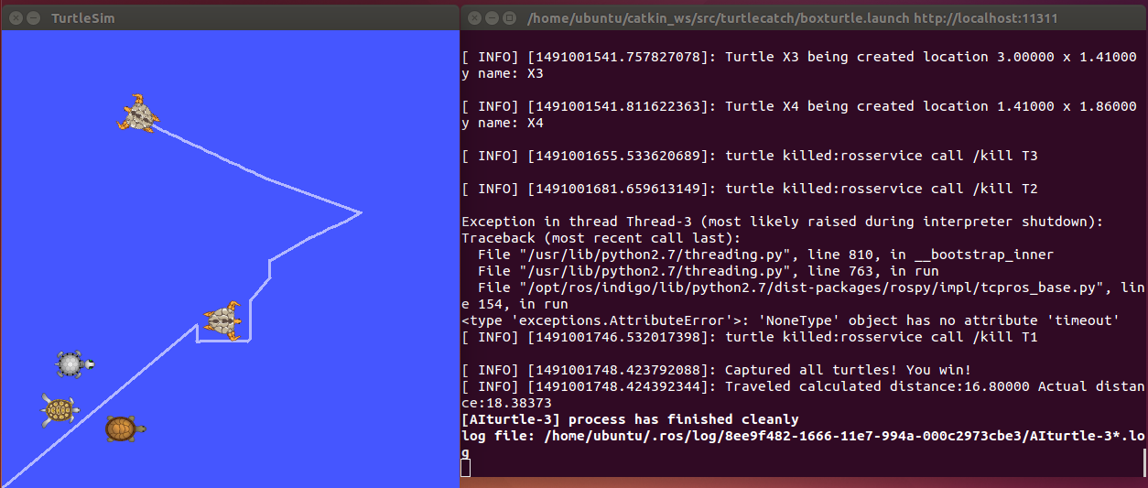

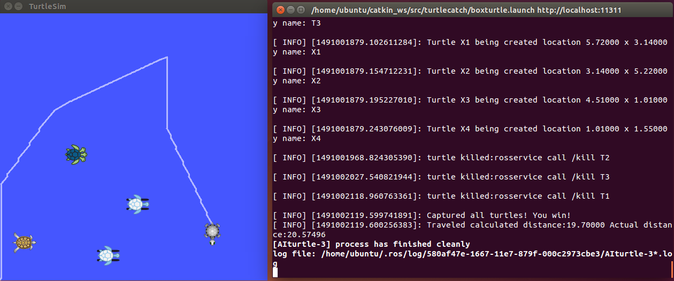

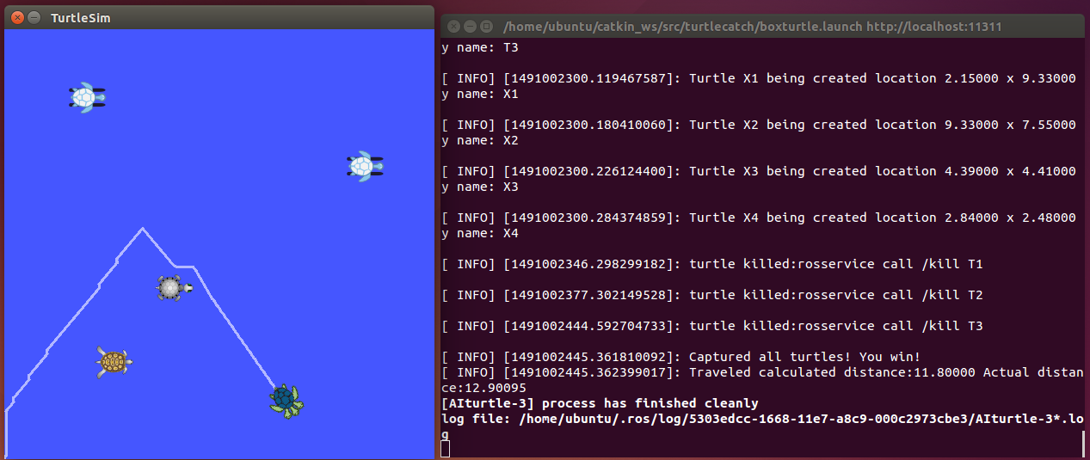

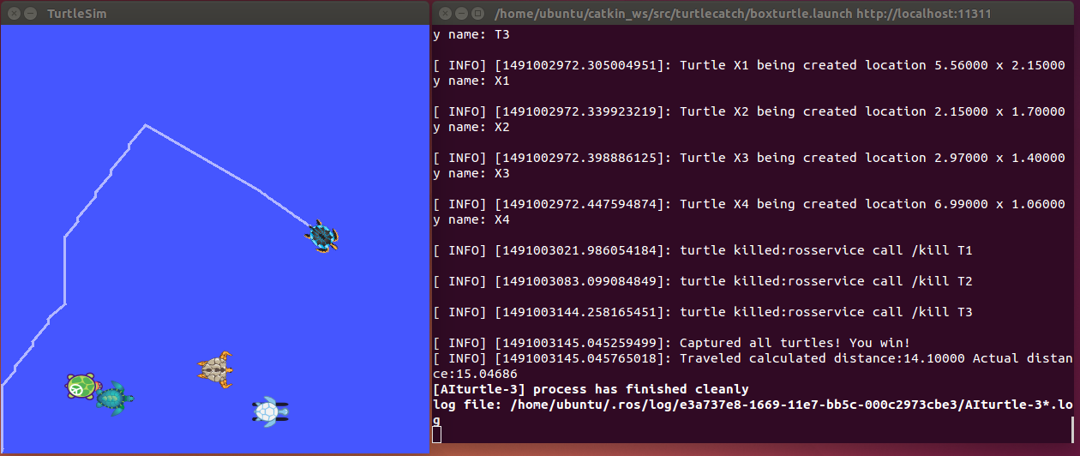

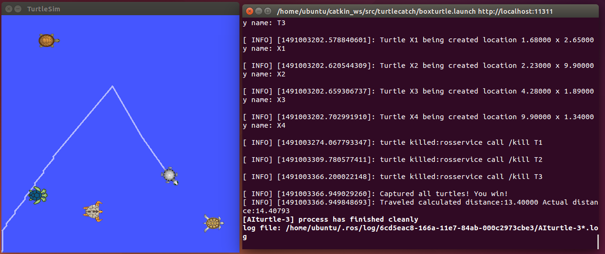

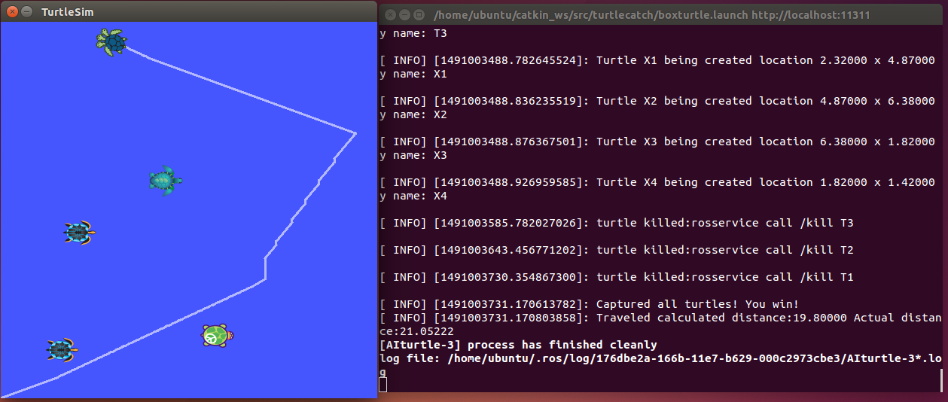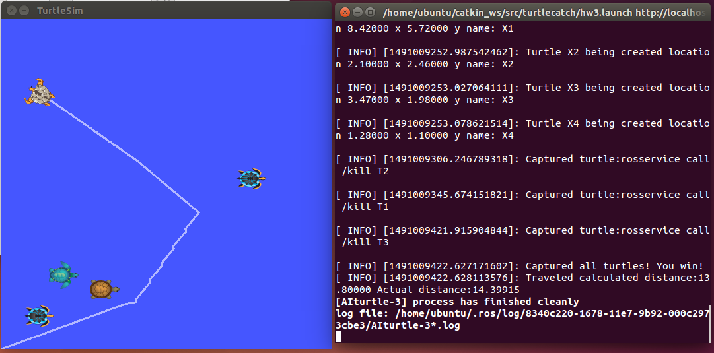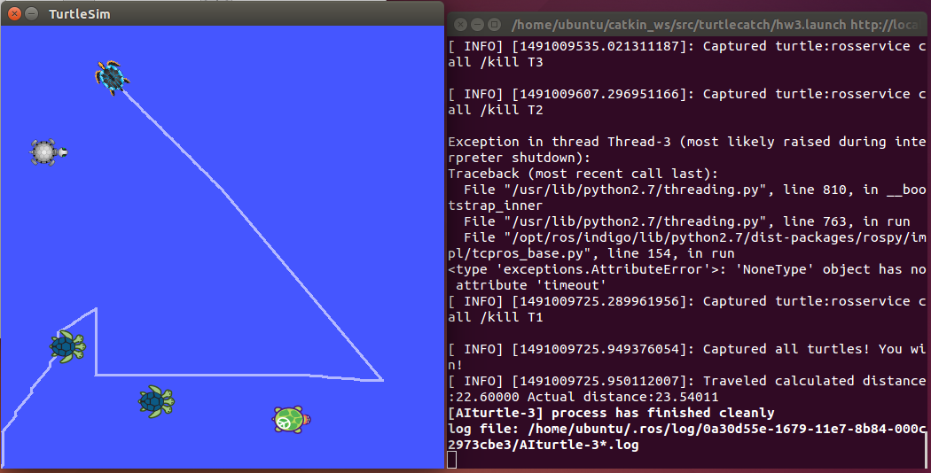

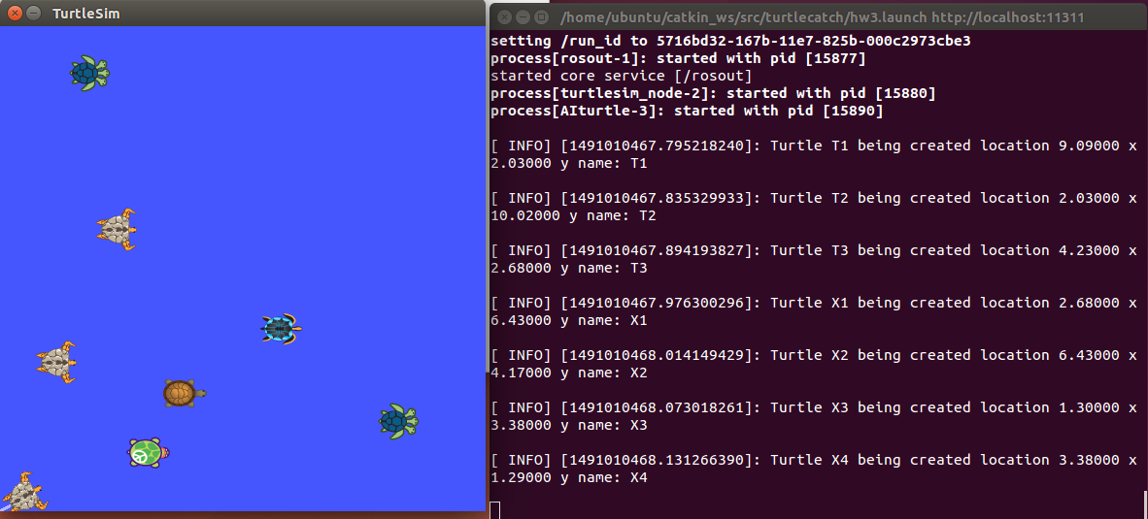

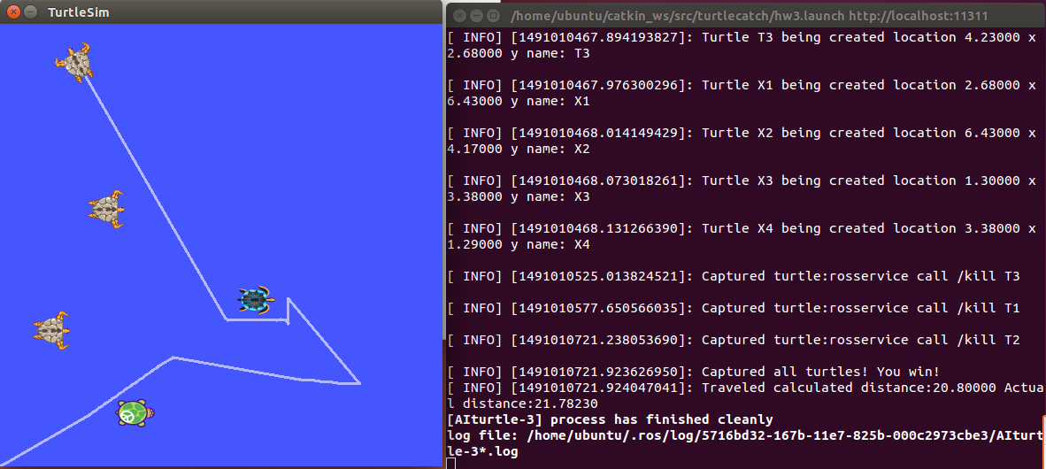

Thao:

Created and uploaded turtlecatch.zip (Renamed turtlebump.cpp to hw3.cpp, made changes to CMakeFile and readme files, added some comments and cleaned up hw3.cpp a little bit)

Long:

Renamed launch file to hw3.launch (turtlecatch_v2.zip)

I see he changes due date to April 10

I have a problem like this: after doing $ catkin_make, the 1st time it runs sometime fail… after that is ok.

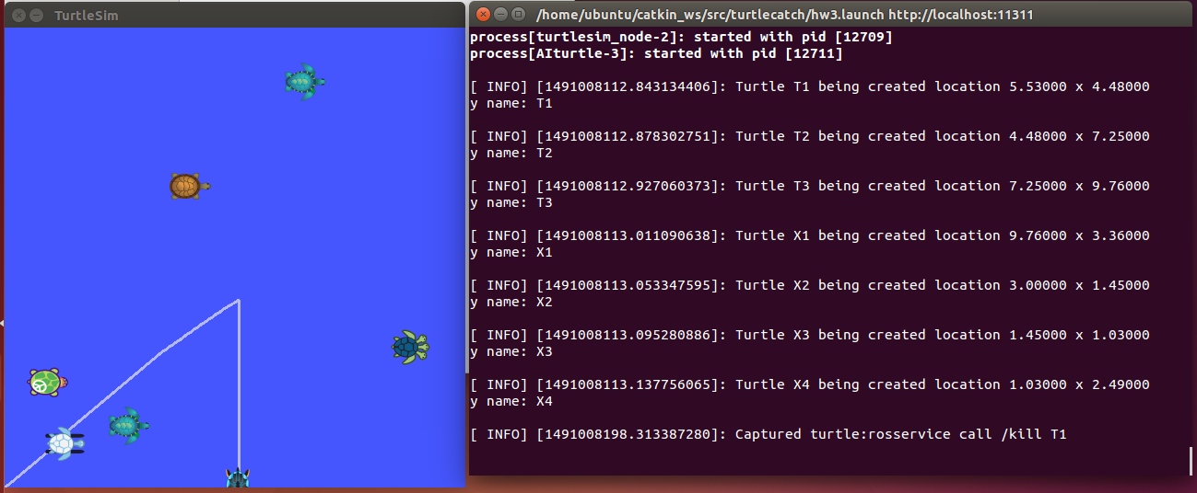

New run on Apr 1 : (1/5)

Start:

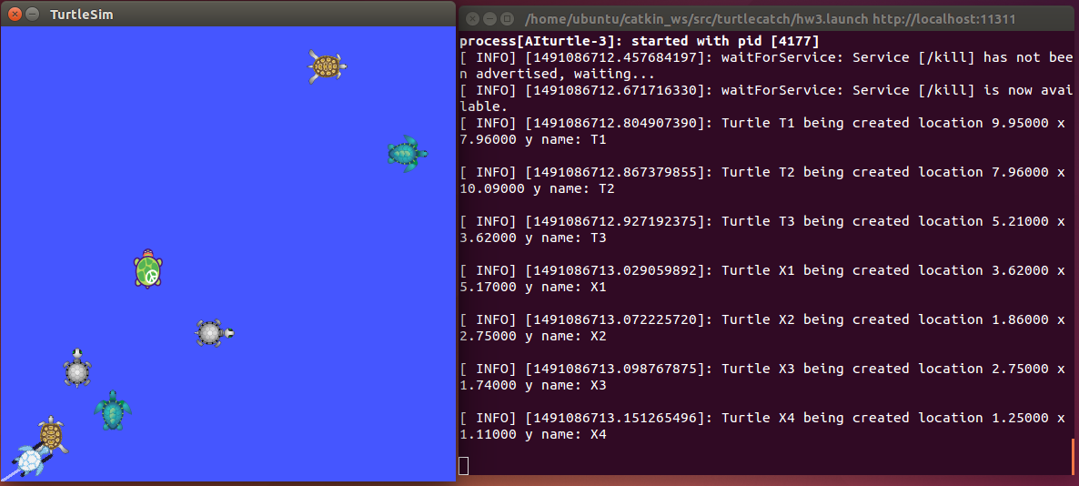

End:

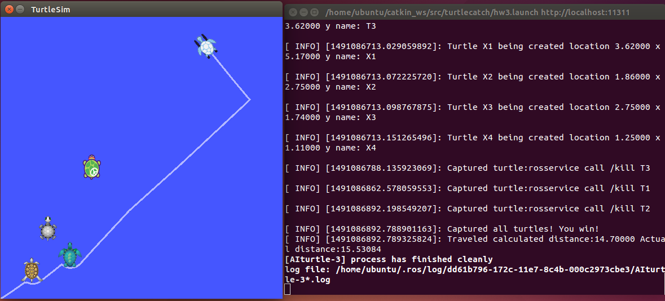

New run on Apr 1 : (2/5)

Start:

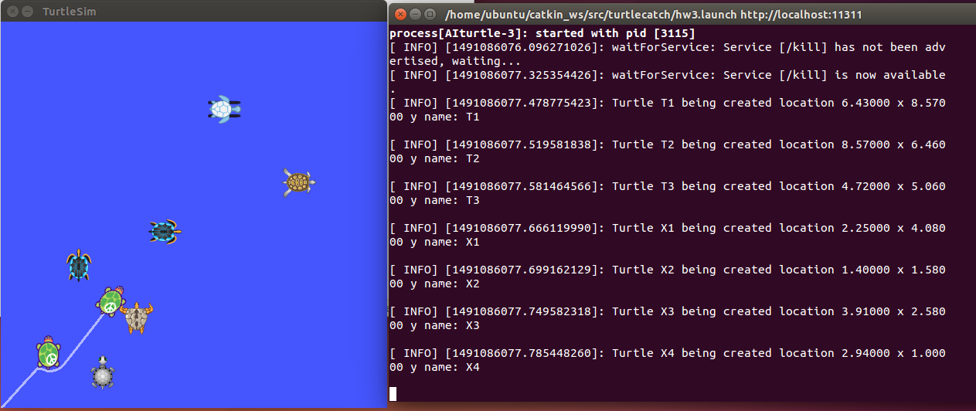

End:

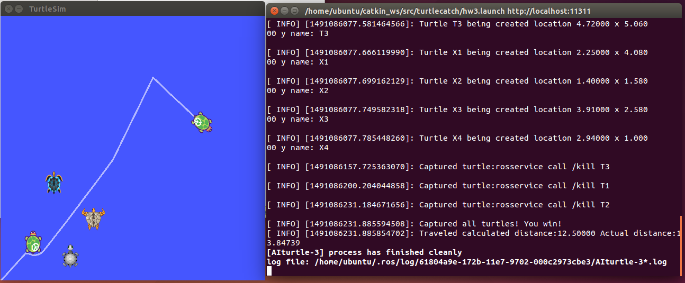

New run on Apr 1 : (3/5)

Start:

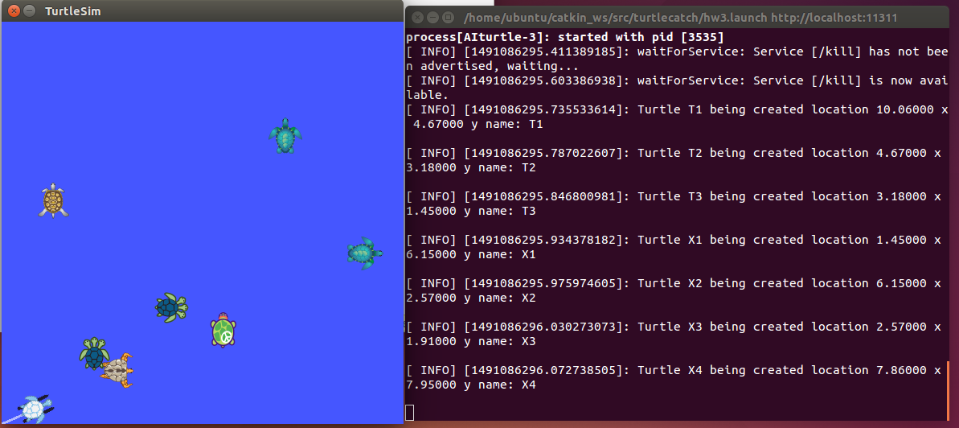

End:

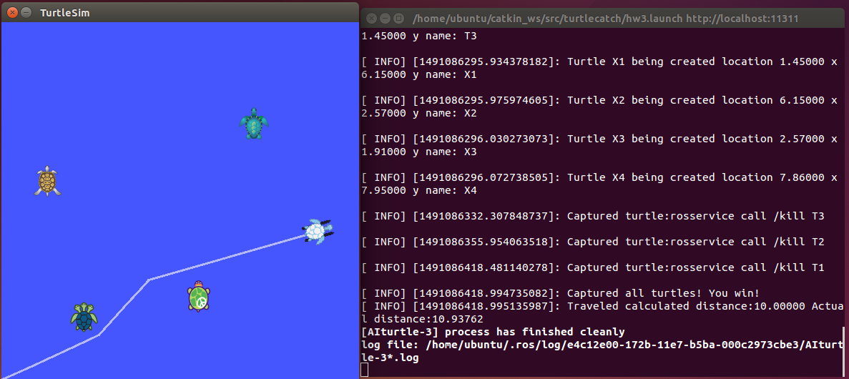

New run on Apr 1 : (4/5)

Start:

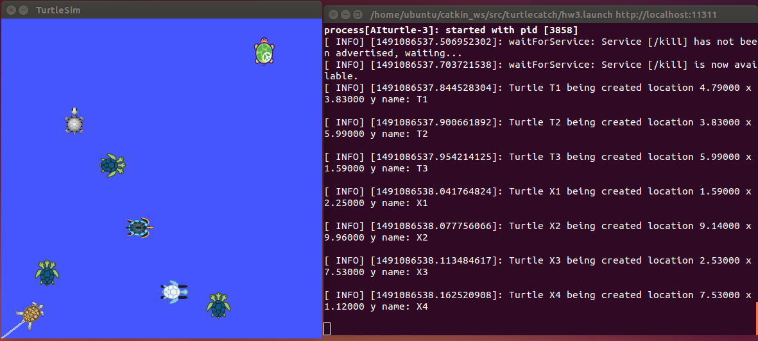

End:

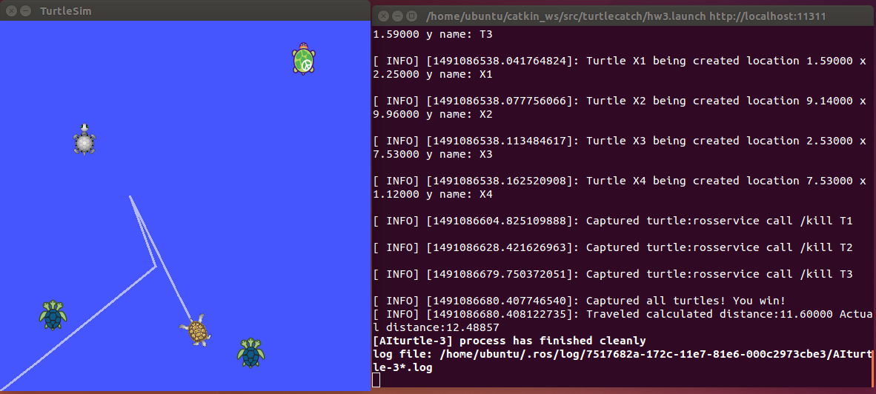

New run on Apr 1 : (5/5)

Start:

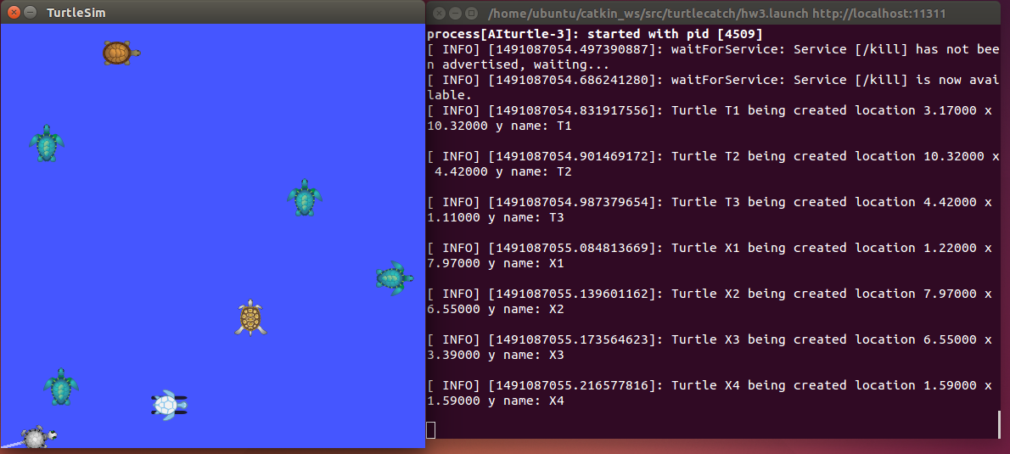

End:

